Consider the following simple network (very similar to example in talk, just with longer and more fiber links):
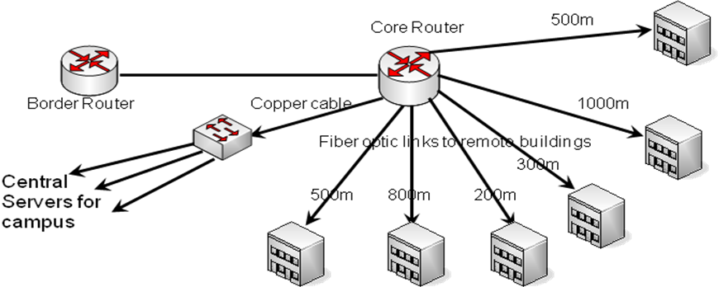
Use the tables below to develop pricing for a network based on gigabit Ethernet and 10gig Ethernet links for all fiber types (OM1, OM2, OM3, OM4, and OS2).
Types of Optical Interfaces
Standard | Speed |  | Supported Fiber |  |  |  | Cost
1000baseSX | 1000Mbs |  | MM |  |  |  | $171
1000baseLX/LH | 1000Mbs |  | MM or SM |  |  |  | $300
10GbaseSR | 10Gbs |  | MM |  |  |  | $780
10GbaseLRM | 10Gbs |  | MM |  |  |  | $930
10GbaseLR | 10Gbs |  | SM |  |  |  | $3,000
10GbaseER | 10Gbs |  | SM |  |  |  | $6,360
Distances Supported by Interfaces
Standard |  | OM1 |  | OM2 | OM3 |  |  | OM4 |  | OS2
1000baseSX |  | 275m |  | 550m | 1km |  |  | 1.1km |  | No
1000baseLX/LH |  | 500m |  | 500m | 500m |  |  | 500m |  | 10km
10GbaseSR |  | 33m |  | 82m | 300m |  |  | 550m |  | No
10GbaseLRM |  | 220m |  | 220m | 220m |  |  | 220m |  | No
10GbaseLR |  | No |  | No | No |  |  | No |  | 10km
10GbaseER |  | No |  | No | No |  |  | No |  | 40km

Cost of Fiber
Fiber Type | Budget Cost per km
OM1 | $3,087
OM2 | $2,203
OM3 | $3,739
OM4 | $4,861
OS2 | $2,150

Here are some worksheets to use.
What is the total installed fiber length? 3300 m
Cost of 1 Gigabit Network
Fiber Type | Fiber Cost | Optics Used | Optics Cost | Total Cost
OM1 | 3087*3.3=  $10,220.10 | Can’t do gigabit on OM1 on links over 275m
OM2 | 2203*3.3=  $7,269.90 | Can’t do gigabit on OM2 on links over 550m
OM3 | 3739*3.3=  $12,338.70 | 12 x 1000baseSX | 12*171=$2,052 | $1,4390.70
OM4 | 4861*3.3=  $16,041.30 | 12 x 1000baseSX | 12*171=$2,052 | $ 18,093.30
OS2 | 2150*3.3=  $ 7,095.00 | 12 x 1000baseLX | 12*300=$3,600 | $ 10,695.00

Cost of 10 Gigabit Network
Fiber Type | Fiber Cost | Optics Used | Optics Cost | Total Cost
OM1 | 3087*3.3=  $10,220.10 | Can’t do gigabit on OM1 on links over 220m
OM2 | 2203*3.3=  $7,269.90 | Can’t do gigabit on OM2 on links over 220m
OM3 | 3739*3.3=  $12,338.70 | Can’t do gigabit on OM3 on links over 300m
OM4 | 4861*3.3=  $6,041.30 | Can’t do gigabit on OM4 on links over 550m
OS2 | 2150*3.3=  $ 7,095.00 | 12 x 10GbaseLR | 12*3,000=$36,000 | $43,095.00

